Nombre: ____________________________ Bloque: ________ Fecha: _______________________
Español 1 - Unidad 5 – La cultura – Ecuador
Instrucciones: Fill out the following notes sheet based on the cultural activities online. This follows the online activity in order by section. Make sure to hold on to this paper to study, as this information will be part of the exam! This can also be used as a backup should you lose internet connection while working.

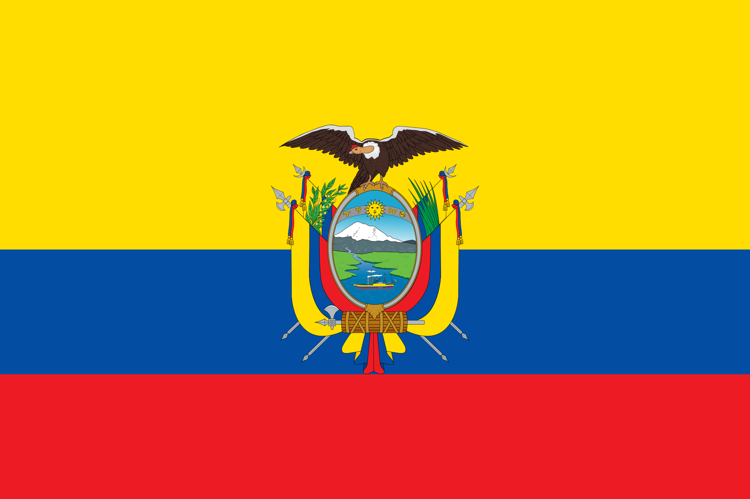
Información general:
- The capital of Ecuador: ____________________________
- Languages spoken: _______________________________________

- Currency of Ecuador: ____________________________
Colors/Design of the flag of Ecuador ________________________
________________________
- Famous Ecuadorian Singer: ____________________________
- Continent: ____________________________
- Country to north-east: _______________________
- Country to the south: _______________________
- Ecuador is located on the line of the ______________________, from which it gets its name.
- The city of Otavalo is to the ____________________ of Quito.
- The ____________________ Islands are also governed by Ecuador.
El fútbol:
- The Selección Nacional is Ecuador's national team in ________________________________.
The Andes Mountains & Cotopaxi Volcano:
- The world's highest active volcano is _______________________ near Quito, Ecuador.
- The __________________________ mountain range stretches north to south along the western coast of South America.
- More than 100 years ago Cotopaxi destroyed the nearby city of ___________________, but it is not expected to erupt for many more decades.
The Otavalo Indigenous Group:
- The painting, Las floristas, by __________________________ shows indigenous (native) women from Otavalo, Ecuador.
- The town of Otavalo, Ecuador is famous for its ___________________________.
- The Otavalan women in the painting are wearing traditional clothing of white ________________________ and layered white and black skirts with red sashes.
- Camilo Egas, an Ecuadorian painter, has many paintings on display at _________________________________ in Quito.
- Otavalo men have a traditional outfit of a blue poncho, white pants, a felt fedora, and a shimba which is a long ____________________.

Casas de Ecuador:
- The Tigua artists are known for their colorful _______________________ created with chicken feather brushes on sheephide.
- The Tigua artists are from the Ecuadorian _________________________.
- Traditional houses in Quito, Ecuador have elements of traditional Spanish architecture. They often have a ___________________________ and red-tiled roof.
Geographic Sites & the Equator:
- The equator devices the northern and southern ___________________________.
- The monument, La Mitad del Mundo (The Middle of the World) in Ecuador, marks the location of _____________________, where you can stand in both hemispheres.
- Ushuaia, in Tierra del Fuego, Argentina is known as La ciudad del fin del mundo (the city at the end of the earth). It is the ______________________ city in the world.

The Ruins of Ingapirca:
- At Ingapirca, Ecuador, the ____________________ built El Templo del Sol which served as a fortress and place of worship.
Fiestas de Quito:
- Quiteños (people from Quito) celebrate Fiestas de Quito on _____________________ honoring the anniversary of the founding of Quito, Ecuador in 1534.
- The week long celebrations of Fiestas de Quito include _________________________, concerts and dances.
- During Fiestas de Quito, musical tributes or ____________________ to the city of Quito.
- Other activities during the Fiestas de Quito include fireworks, beauty pageants (Reina de Quito), and building _________________________.
More About the Otavalo People:
- The town of Otavalo, Ecuador is famous for its Saturday _____________________.
- The Otavalo indigenous group is famous worldwide for its ________________________ and have been weaving for centuries.
- Landscapes, animals, and ______________________ patterns are common designs of Otavalo weaving.
- The Otavalo people have found success with their markets and selling their artwork/textiles both _____________________________.
Folkloric Dances:
Ecuador:
- Folkloric dances in Latin America represent a __________________________ cultures and help form a national identity.
- A folkloric dance from Ecuador is the _________________________.
Panama:
- The national dance of Panama is the __________________________ which combines African rhythms and Spanish and indigenous traditions.

